IOT Smart Energy Grid

Energy generation companies supply electricity to all the households via intermediate controlled power transmission hubs known as Electricity Grid. Sometimes problems arise due to failure of the electricity grid leading to black out of an entire area which was getting supply from that particular grid. This project aims to solve this problem using IOT as the means of communication and also tackling various other issues which a smart system can deal with to avoid unnecessary losses to the Energy producers.
IOT Smart Energy Grid is based on ATmega family controller which controls the various activities of the system. The system communicates over internet by using Wi-Fi technology. A bulb is used in this project to demonstrate as a valid consumer and a bulb to demonstrate an invalid consumer. The foremost thing that this project facilitates is re-connection of transmission line to active grid. If an Energy Grid becomes faulty and there is an another Energy Grid, the system switches the Transmission Lines towards this Grid thus facilitating uninterrupted electricity supply to that particular region whose Energy Grid went OFF. And this information of which Grid is active is updated over IOTGecko webpage where the authorities can login and can view the updates. Apart from monitoring the Grid this project has advances capabilities of monitoring energy consumption and even detect theft of electricity. The amount of electricity consumed and the estimated cost of the usage gets updated on the IOTGecko webpage along with the Energy Grid information. Theft conditions are simulated in the system using two switches. Switching one each time will simulate a theft condition and also will notify the authorities over the IOT interface. In this way the Smart Energy Grid project makes sure that the electricity supply is continuous and helps in maintaining a updated record of consumption and theft information which is quite a valuable information for the energy producing companies.

Block Diagram:
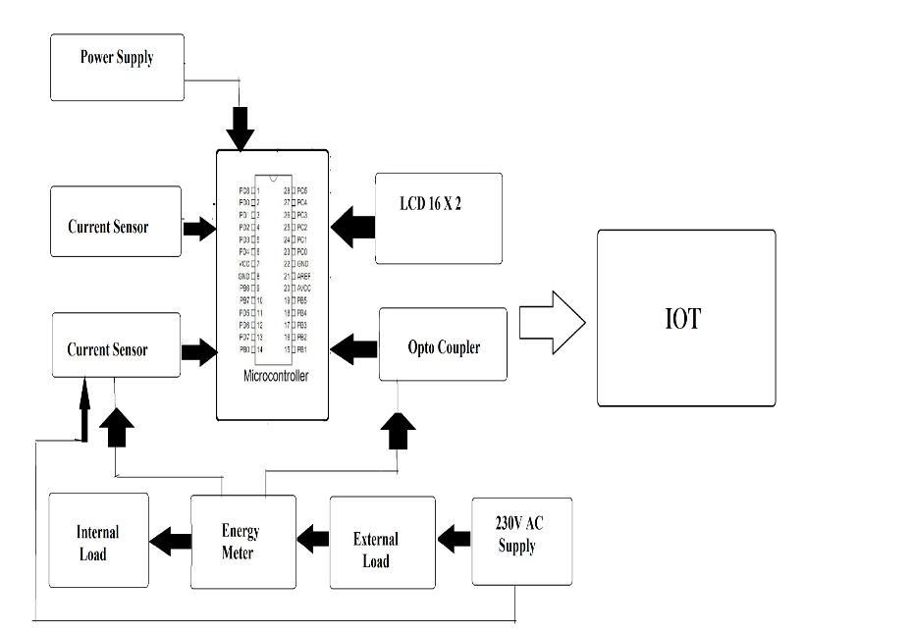

Hardware Specifications
- ATmega328P AVR MC
- Optocoupler
- Current Sensor
- Energy Meter
- ESP8266 Wifi Module
- LCD’s
- Crystal Oscillator
- Resistors
- Capacitors
- Transistors
- Cables & Connectors
- Diodes
- PCB
- LED’s
- Transformer/Adapter
- Push Button
- Load (Lamps)

Software Specifications
- IOTGecko
- Arduino Compiler
- MC Programming Language: C

